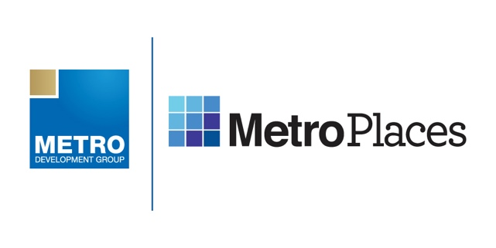
Metro Development Group Breaks Ground on
New K-8 School Within Connected City
Enrollment Now Open at Innovation Preparatory Academy (inPrep) in Wesley Chapel

Tampa, FL (February 20, 2020) – Tampa-based developer Metro Development Group has announced plans for the next phase in the development of its Connected City in Pasco County, FL – a charter school named Innovation Preparatory Academy, or simply inPrep. The school will be built within the campus of the soon-to-be-named Connected City which encompasses two Metro Places communities, Epperson and Mirada, each with its own multi-acre Crystal Lagoon and Metro’s exclusive ULTRAFi high-speed internet technology.

Built in partnership with Metro Development Group, Red Apple Development, Pasco County School District and other industry leaders, inPrep will open as a K-8 school, initially enrolling incoming K-6 students at the start of the 2020-2021 school year. It will expand year to year allowing inPrep students transitioning from sixth to seventh and then seventh to eighth grades to continue on at the academy with maximum enrollment for all grades at 765 students. Charter Schools USA will serve as operator.

The curriculum at inPrep is based on the WISH approach of Wellness, Innovation, Science and Health with classrooms that are both open and modular depending on the course so that the setting serves to complement the subject matter. Additionally, the innovative school has plans to offer the Cambridge Program, designed by England’s University of Cambridge, to meet the needs of gifted and high-achieving students through a rigorous curriculum aimed at developing critical thinking skills and fostering collaboration.

This is just the latest in exciting announcements pertaining to Metro’s Connected City. The developer also recently celebrated the opening of the nation’s first Crystal Lagoons amenity, earned the distinction of the first Smart Gigabit Community built from the ground up, installed its 300th eco-friendly, solar-powered streetlight known as Metro iLights and announced a partnership with AdventHealth that will provide 21st century health and wellness initiatives, with initial focus on tele-health services within the homes of its residents.

Metro’s exclusive ULTRAFi technology (which provides the fastest internet speeds available with up to 1 Gigabit of speed) serves as the framework for inPrep’s connectivity and will enable it to become one of the most advanced schools in the area.

“In building and launching this one-of-a-kind educational component, Metro Development Group is demonstrating its continued focus on innovation and furthering its commitment to creating a better future for children living in or near its communities,” said Metro President Greg Singleton at today’s groundbreaking event which included representatives from the developer, Pasco County commissioners, Pasco school district and more. “We are excited to partner with Red Apple, Charter Schools USA and Pasco County, amongst others, and look forward to working together to provide a world-class educational experience beginning this fall.”

“We are committed to developing only the highest-quality educational facilities and are excited and honored to work alongside Metro Development Group to bring what will be one of the most innovative charter schools in the country to its Connected City,” said Red Apple Development President Scott Woodrey.

Those interested in enrolling and/or learning more should visit www.inPrep.com

As construction on inPrep ramps up, Metro will look ahead to the next phases of development within the Connected City including WiFi parks, autonomous vehicle paths, a modern business/retail core and much more to make this an authentic model for 21st century living and robust job creation. For more information about the Connected City, visit www.ConnectedCityFlorida.com

About Metro Development Group
A Tampa-based company founded in 2003, Metro Development Group is committed to bringing some of the most innovative technologies and amenities to homebuilders and homebuyers. With the introduction of the Connected City, Metro Places, ULTRAFi and Metro Lagoons by Crystal Lagoons, Metro continues to be the gold standard in the development of master planned communities. For more information, visit www.MetroDevelopmentGroup.com

About Red Apple Development
Red Apple Development was created in 2007 to address the needs of charter school growth across the United States. Our attention is focused on the acquisition, design, and development of private, public, and charter school facilities. We provide owner’s representation management services that facilitate the development of high quality, well-planned learning environments.
###

