Good morning, (Name):
Have you lost your healthy glow? Are you forgetting your family members’ names? Or having trouble leaving work at work? If you answered “yes” to any of these questions, you could be suffering from one of the many maladies associated with Vacation Deficiency.
In fact, it’s rumored that 90 percent of all Americans are chronic sufferers of “Pale-a-tosis”, “Famnesia”, “Cant-relaxia”, “Need-a-vacation-itis” or a related illness, especially now as some of the year’s worst weather descends upon (Feeder Market). While the side effects are not always pretty, five out of five people who know a doctor agree on a one-stop cure: a trip to the Bradenton Area (Bradenton, Anna Maria Island, Longboat Key) on Florida’s West Coast.
Offering serene (and pristine) island beaches, award-winning waterfront restaurants, quaint but vibrant downtowns, sprawling nature preserves, an undeniable “Old Florida” feel, countless family-friendly activities and more – all within minutes of the Sarasota Bradenton International Airport which offers (Daily) non-stop flights from (Airport) on (Airlines) – a trip to Bradenton Area would have you on the road to recovery stat. The only unavoidable side effect is that you might not want to leave.
Still not convinced you’re suffering from Vacation Deficiency or that you should consider accepting my invite to experience the destination for yourself to treat what ails you? Please visit our very scientific Online Symptom Checker to receive an official diagnosis and receive more information about a personalized treatment plan available only in the Bradenton Area.
I hope we can host you for a press trip and get you on the road to recovery soon. We can find a time that works for you, but when you’re living with Vacation Deficiency time is of the essence.
Hope to hear from you soon.
Megan
Megan M. Brewster
Aqua Marketing & Communications, Inc.
(617) 285-0771

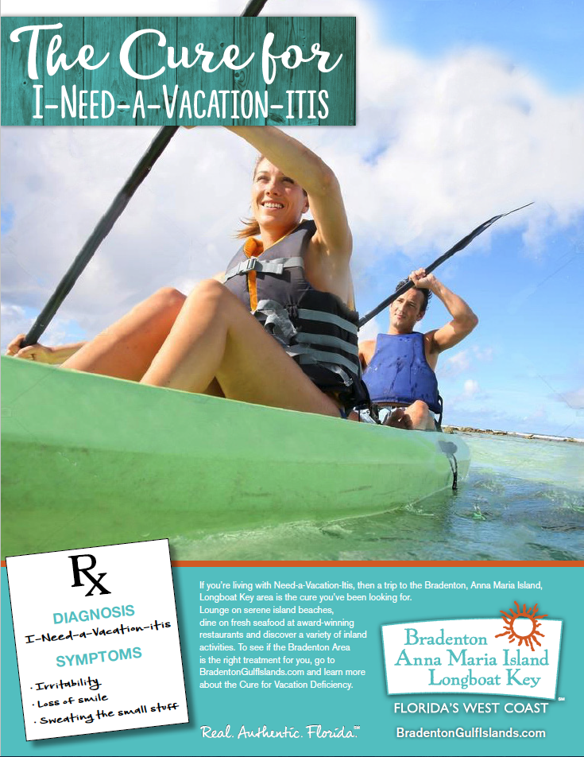

The cure for vacation deficiency
Need-a-Vacation-itis
Symptoms: irritability, loss of smile, inability to appreciate life’s precious moments
and a higher risk of sweating the small stuff.
Pale-a-tosis
Symptoms: loss of healthy glow, vitamin D deficiency, being mistaken for a ghost.
Fam-nesia
Symptoms: forgetting what your children’s laughter sounds like, not noticing your partner’s new hairstyle, mistaking your own family members for strangers.

